Little Lambs
Handbook
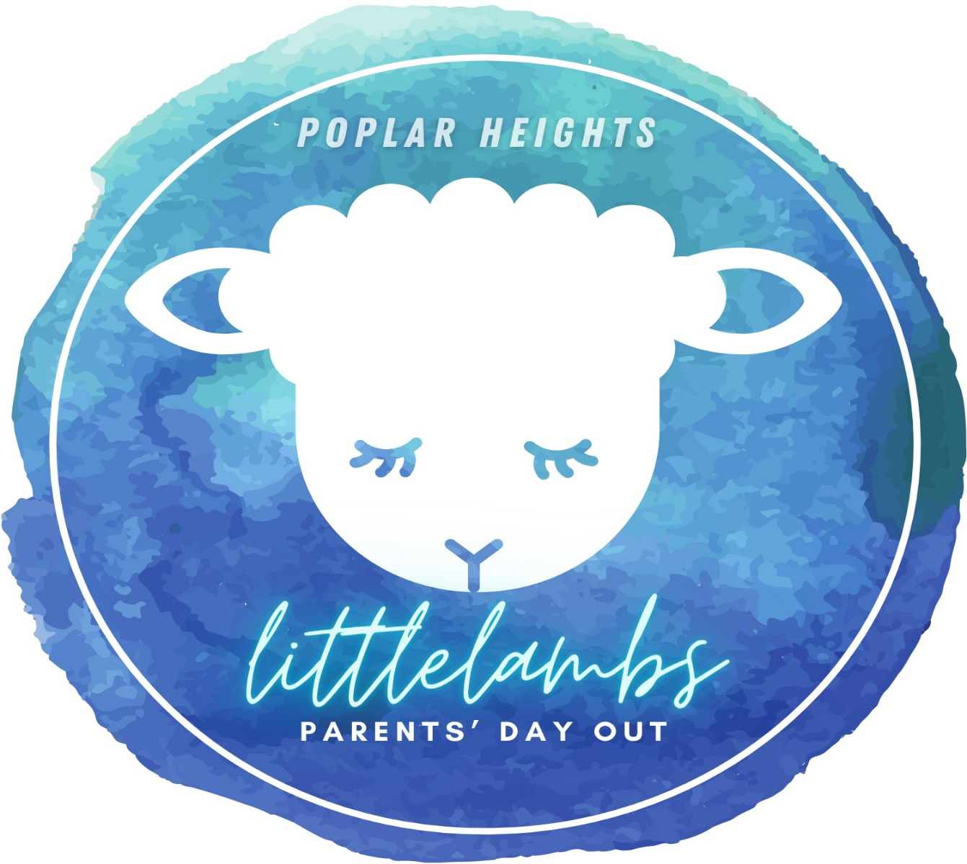
Welcome
We are so excited about all the wonderful things that God is doing in our program. Each month we have a different theme with exciting special days planned specifically to go along with that month. We hope you will join us as we journey through God’s word and learn together.
About us

Little Lambs is an exceptional parent’s day out program that meets on Tuesdays and Thursdays. The purpose of Little Lambs, PDO is to provide a safe, fun, Christian environment where families are given a biblical foundation for life. We desire to come along side parents who are seeking a unique Christian environment to help lay a biblical foundation for life. We do this by incorporating biblical truths into day’s activities as well as a chapel service uniquely designed for children on Thursdays. The program operates on Tuesday and Thursday from 8:30am – 2:30pm. Monthly Tuition is $180.00 due on the first Tuesday of each month and a registration fee of $50 a semester that will cover snack and craft supplies. The day begins at 9:00 a.m. and ends at 2:30 p.m. Doors will be open at 8:45m for drop-off and 2:15pm for pick-up. Please Park in designated parking places. It poses a danger to others who are arriving and leaving when cars are pulling up to or out of the awning area. Do pull up at any time if you need assistance getting multiple children out of the car. If you need to pick up or drop off at a different time just notify us and we will assist you.

This facility is not required to be licensed by the state as a childcare agency.71-3-503(b)(1)(2)
Parents Signature____________________________________________________________

Curriculum

We do not use any established curriculum. We do use the Bible as our foundation for truth. Children learn primarily by watching, hearing, and doing, through experiences in work and play. Therefore, we will provide both structured activities as well as free play time. Our curriculum is biblically centered. All other learning activities, such as colors, shapes, letters, numbers, phonics, etc., will be incorporated into or correlate with the Bible Story and verse for the day.

Enrollment

- __Turn in your completed Registration Form and non-refundable Registration Fee of $50 for each month’s enrollment (this covers craft and snack supplies). This will hold your enrollment space.

- __Submit your proof of immunization. Bring a hard copy or a copy may be faxed to the church at the number: 731-668-6732.

- __We will need a copy of your Driver’s License, Health Insurance card and Drivers Insurance card to keep in your child’

- __Submit your monthly tuition on the first Tuesday of each month. Please communicate with me should you have questions.

- __Please note that by filling out the registration form and signing it, you are committing to pay for the full monthly enrollment. We make enrollment commitments to our teachers and thus we need that commitment from our families.

- __Admission to Little Lambs is based on availability and the age of your child. When we no longer have an open enrollment positions, a waiting list will be established. Priority will be given to siblings of currently enrolled children. Otherwise, individuals will be placed on the waiting list on a first come, first-served basis.

- __When withdrawing your child from Little Lambs, a written two-week notice is required. If no notice is given, you will be required to pay tuition for the additional two weeks.

- __Tuition is based on enrollment NOT attendance. Full payment is required even if the child is not in attendance, regardless of absences or closings.

- __No credit will be given for illness, vacation, center closing due to an emergency, inclement weather, or unprecedented event. Little Lambs reserves the right to close the center for weather or safety-related reasons.

- __Non-payment of tuition is grounds for immediate dismissal from our program.

Policies and Procedures

__Safety and security are very important to us at Little Lambs. Our doors will remain locked throughout the entire day except for during our pick-up and drop-off times. Guests will be able to ring the bell and gain entry. If you are here at any other time, please call us or ring the bell and we will be happy to help you. Children must be signed in and out daily by the parent. If your child will be absent, or will be arriving later than 10:00 am, we ask that you call so that we can prepare for adequate staffing. Please inform your child’s teacher if someone other than you will be picking up your child. You will be asked to provide names of those individuals who are approved to pick up your child in the application procedure as well as a picture ID and to show us the Little Lamb ID Card upon arrival these will need to be presented to our staff. Little Lambs reserves the right to refuse to release a child to a person who appears physically, emotionally, or mentally unable to provide adequate care for the child as judged by the staff member responsible for the child. In the event the situation should arise, staff will release the child to an authorized individual on the child’s emergency contact list who appears able to provide appropriate care for the child.

Student ID Cards
____ Student ID Cards are mandatory. Each parent and Authorized individual listed on your registration form will need to have an ID Card and show it to your child’s teacher upon pickup. If you do not have the ID Card, we will not be able to release your child. Upon registration we will issue you your cards. The fee is $1.50 for your two initial cards. For any additional cards, the fee is .75 for each additional card. These are payable at the time of registration.

Late Pick Up

__Late pick up fees are put in place to cover the staff after Little Lambs closes. $10.00 for the first 5 minutes past 2:30, then $1.00 per minute after that. Payment will go directly to the teacher who stays with the child. If there is an emergency and you are unable to make arrangement needed for on time pick-up, please contact the director.

Dress/Attire

__Part of creative learning means FUN! When choosing your child’s clothing, bear in mind that sometimes our fun can be messy, too! For this reason, please follow our clothing policies to ensure your child gets the best experience.
*Please dress your child in seasonally appropriate and comfortable play clothes.
*Each child should have at least one complete change of seasonally appropriate play clothing. Please be sure to replace any articles of clothing that are used from the spare set.
*Please label ALL items (including clothing, coats, hats, bottles, baby food, bags, and sippy cups) that you bring to Little Lambs with your child’s first and last name.
*Children MUST always wear shoes.

Personal Belongings

__Please refrain from allowing children to bring personal belongings to Little Lambs other than those we request. For the safety and well-being of all the children, we ask that you do not allow your child to bring toys from home except on special “sharing” days. We are not responsible for personal items or toys from home that get lost or broken. Any items brought for a special reason requested by teachers need to be labeled appropriately with the child’s first and last name. Labeling your child’s items is the best way to ensure they do not get misplaced.

Infants (6 weeks - 12 months)

__Please bring the following supplies, labeled with your child’s first and last name:
* Prepared bottles- Breast milk should be brought in pre-made bottles ready to warm and serve. These will be refrigerated immediately until feeding time. Formula bottles should be brought in filled pre-measured formula for each bottle. We will mix formula with room temperature filtered water upon scheduled feeding.
* Two complete changes of seasonal clothing and bibs
* Diapers and wipes
* Any cereal or unopened food.
Sudden Infant Death Syndrome (SIDS) special note:
We are proactive against SIDS. Cribs will only contain a sheet per state regulation. Mobiles, stuffed animals, extra blankets, and propping will not be allowed. Infants in cribs are checked every fifteen minutes during napping times.

We have several specific policies in place to ensure the safety and well-being of our infants.
* Infants may not sleep in swings or bouncers for more than 30 minutes
*Teachers may not swaddle children, but sleep sacks are permitted

Toddlers and Twos (12 months - 2 years)

__Please bring the following supplies, labeled with your child’s first and last name:
* Diapers and wipes
*A complete change of seasonal clothing including socks and underwear (if applicable)
* Sippy cup, lunch (finger foods), we provide a morning snack
* Mat for nap (a king size pillowcase fits for cover), blanket, animal or lovey is fine to bring

Preschoolers (3 years - 5 years)

__Please bring the following supplies, labeled with your child’s first and last name:
* A complete change of seasonal clothing including socks and underwear, pullups, and wipes (if applicable)
*Sippy cup, lunch, we provide a morning snack
* Mat for quiet time (a king size pillowcase fits for cover), blanket, animal or lovey is fine to bring

Communication

__Communication is a top priority for us. We provide daily sheets with detailed information about your child’s day. This will include details about meals, snacks, diaper/potty, nap times, activities, your child’s behavior, and activities, and needed items (diapers, wipes, clothing, etc.). Please provide your child’s teacher with any special instructions to help us serve your child better. Our teachers are greeting each of you in the morning and afternoon to communicate on anything for that day as well as director in the foyer area. Please remember, drop-off and pick-up times are considered transition times for a classroom and can be busy. These transition times are not the best time to address your child’s growth or development. Please let the director know your question or request to schedule an appropriate time to discuss your child’s needs. Do not hesitate to contact director anytime.

Parent Participation

__We welcome parent participation for the improvement of our program. We have several regular opportunities for class participation, such as reading in your child’s class, sharing special family traditions or cultures, assisting with parties, and volunteering in the class. Additional ideas and suggestions are always welcomed and appreciated!

Birthday Policy

__We love to celebrate! If you want to celebrate your child’s birthday, feel free to bring in food (cupcakes, cookies, etc.) or party favors. Any food items brought in MUST be checked on with teacher before for food allergy concerns for classroom. If you are handing out favors or invitations to parties outside of the school, you MUST bring enough for each child in the classroom, or the school cannot distribute them.

Holidays and Special Events

__We will also celebrate holidays and special events. You will be given an opportunity to sign up to bring developmentally appropriate food choices, goodies, and paper goods throughout the year for celebrations.

Diapering and Toilet Training

__For children still in diapers, cleanliness is an essential factor of maintaining an appropriate level of care. Therefore, diapers/pull-ups will be changed when soiled or at minimum every hour and a half to two hours. Diaper changes will be noted on the child’s daily activity sheet. The TN Diapering System will be used for all diaper changes to minimize contamination.

Toilet Training

__When you are ready to start toilet training your child, we ask that you let us know what routines you are using at home so the teacher can do the same in the class. Consistency is key when toilet training. Please bring any supplies such as a few pairs of extra clothes, including socks and shoes, to put in the child’s cubby for any accidents.

Transitions

__As your child grows and develops through Little Lambs, he or she will transition from one class to another. We strive to make this as stress-free as possible, not only for the child but for you as well. There are many decisions involved in promoting children to the next class. Children are assessed by age as well as terms of their development. Interest level in the activities is also taken into consideration. The teacher and parents will be consulted, and you will receive information about the next transition.

Discipline Policy

__Discipline is always in a manner which protects your child’s dignity and wellbeing. Physical punishment will never be allowed. Discipline will be consistent and fair. The staff will use positive reinforcement and re-direction techniques. First, the child will be redirected verbally. If the behavior continues, the child may be placed in the safe space separate from the group, but still within the classroom. If behavior escalates, cannot be controlled, or becomes violent towards others, the Director will be involved and will contact parents to get involved in the process. This may include the request for the child to be picked up for the day. Behavioral issues that cannot be resolved may result in dismissal from the program.

Biting Policy

__Biting is an age-appropriate stage of development for infants, toddlers, and on occasion preschoolers. In a group setting, most children will attempt biting at least once. When biting occurs, our focus will be on the children to determine why the biting occurred and what we can do to help. Communication between teachers and parents will be a key aspect in reducing this behavior. Incident will be documented to be kept on file and signed by parents. In some cases, a child may be dismissed if biting does not stop.

Child Abuse Policy

__Little Lambs will comply with all Tennessee State laws in reporting any suspicion or evidence of child abuse. The Child Abuse Hotline (or 1-800-4-ACHILD) will be contacted, and a report will be filed. A report will be made to the police, if necessary, to ensure the safety and well-being of the child. The Department of Human Services will then be notified, and an incident report will be filed within 24 hours.

Holidays

__We follow the Jackson-Madison County School System Calendar for Spring Break, Fall Break, Thanksgiving Break and Christmas Break.

Vacation/Break Policy

__Tuition payment is for enrollment in our program and not for attendance. We are a year-round program that enrolls by fall, spring, summer semesters.

Inclement Weather Policy

__Normal hours of operation are subject to change at any time to ensure the safety and well-being of your children and our staff. Emergency conditions cannot always be predicted with accuracy, so please be prepared for short notices in snow or ice days. Due to the unavoidable occurrence of emergency weather conditions, please remember any closure is to protect the well-being of the children in our care.
To receive news quickly you will receive a text, and this will be posted on our social media

Illness Policy

__Little Lambs will communicate with you about any health issues that are noted while your child is at our center. As a courtesy to all children and staff, please keep the staff informed about any health issues your child may have. To protect the health and well-being of all children and staff, the following health procedures and policies will be followed:
- We cannot admit a child who has any contagious illnesses or symptoms, including but not limited to:
  - A fever over 100 degrees
  - Vomiting
  - Diarrhea
  - Open sores & mouth sores
  - Unexplained or communicable rashes
  - Severe mucus drainage
  - Conjunctivitis (a.k.a. pink eye)
  - Exposure to or tested positive with Covid-19

- If your child becomes ill with any of the above while at Little Lambs, we will notify you and the child must be picked up within one hour of contact. Little Lambs reserves the right to require a child to be picked up immediately for suspected contagion. You will be notified should your child be exposed to a contagious illness.
- Your child must be symptom and medication free for 24 hours before returning to Little Lambs.
- We reserve the right to request a physician’s statement prior to readmitting a child to Little Lambs.
- Little Lambs does not administer medication to any child. (See Medication Policy)

Medication Policy

__We do not dispense any over the counter or prescription medication unless REQUIRED by a physician to be medically necessary. Medical equipment and emergency medication must be supported by written and signed release from a physician that will be kept in your child’s file. Teething tablets and Orajel must be accompanied by a completed medication authorization form to be administered while child is in our care. All authorized medication is to be administered by Director only unless permission is given to teacher by a parent.

Lice Policy

__Children must have proof of treatment and be nit free before returning to Little Lambs. Director will check to make sure child is free of lice upon returning.

Accidents/ Incidents

__Safety is an important part of our jobs. We believe it to be our top priority to keep your children safe each day. Although we have many procedures in place to prevent accidents, sometimes accidents are unavoidable. In the event your child has a minor injury such as a bump, scrape, bite, etc. we reserve the right to treat your child with the proper First Aid Care and will contact you to inform you. We will also fill out an accident/incident report that will need to be signed by you or the person picking up your child that day.

Emergency Medical Procedures

__In the event your child requires emergency medical treatment, center staff will call 911 immediately. If your child requires emergency ambulance transportation, the ambulance drivers will transport your child to the closest local hospital at their discretion and depending on the speed with which your child must be treated. Decisions as to the necessity of emergency medical treatment will be made by the Director or another staff member standing in their position. Parents or legal guardians of the child will be notified as soon as possible and will be responsible for all medical expenses related to the child’s injury including any medical transportation. It is the parent or legal guardian’s responsibility to provide insurance information to medical personnel. Our employees are not responsible in any form for medical or transportation expenses.

Natural Disaster Plan

__In the event of a natural disaster (e.g., tornado, threatening winds, etc.), the children will be moved to an inside room of Little Lambs in accordance with Little Lamb’s approved emergency action plan. A weather radio will be always maintained for updates on threatening conditions, as well as flashlights, first aid kits, and other necessary items. Parents will be notified as soon as possible. The Department of Human Resources will be informed in the event of an actual disaster, and an incident report will be filed within 24 hours.
In the event the situation requires evacuation such as a fire, each of our classes will evacuate to the back field next to the picnic pavilion and parents will be notified as soon as possible.

Sunscreen Policy

__During the summer months, the children are frequently outside exploring and learning. Please apply sunscreen to your child in the morning before you bring them. Label with first and last name and bring some for the day, our teachers can reapply as needed.

Daily Routine

__Schedules are designed to be appropriate for the age and developmental level of the group, each class will look different. The day will include Children’s Ministry Time, chapel, arts & crafts, circle/group time for that day’s lessons, free play, group activities, snack time, gym time, playground, fun-zone area, lunch, rest time, worship, and our extracurricular themed activities to go with that month. Please check with your child’s teacher to see their regular schedules.

Rest Time

__Rest times are scheduled after lunch. Children are not required to sleep but must rest quietly as to not disturb other children who are sleeping.

Outside Play

__During a normal daily routine and weather permitting, children will play on the playground. If weather conditions do not permit outdoor play, other gross motor activities will be substituted. The children will also have indoor play in the gym area with riding toys and balls and our toddlers have playtime in our indoor fun-zone.

Policy Changes

__Policies are subject to change at any time. Every effort will be made to notify parents in a timely fashion of any changes to the policies or procedures.

Parent Acknowledgement
*This facility is not required to be licensed by the state as a childcare agency.71-3-503(b)(1)(2)
Parent Signature __________________________________Date ________________________
Director Signature ________________________________ Date ________________________

I, the parent / guardian of ________________________________________________________
Child’s Name
acknowledge that the Little Lambs, PDO Handbook Policy was explained to me, and I have read and received a copy of the Little Lambs, PDO Handbook Policy.
_______________________________________________ ____________________________
Parent Signature Date
_______________________________________________ _____________________________
Director Signature Date

